Object Model

G-Squared Time Tracker

Catt Software



Submitted By: Russell Hurtado

Submitted To: Calvin Caldwell

E-mail: russell.hurtado@oit.edu

Date: 11/08/16

Release: 1.0

Version: 1.0

1 Signatory Page

This documented accepted by:

_________________________________ __________________

Signature (Calvin Caldwell) Date

This documented accepted by:

_________________________________ __________________

Signature (Russell Hurtado) Date

2 Revision History

|  |  |  |  |  |  |
| --- | --- | --- | --- | --- | --- |
| Author | Company | Version | Date | File Name | Comments |
| Russell Hurtado | Catt Software | 0.1 | 11/08/2016 | Object Model.docx | First draft of the Model |
|  |  |  |  |  |  |
|  |  |  |  |  |  |
|  |  |  |  |  |  |
|  |  |  |  |  |  |
|  |  |  |  |  |  |
|  |  |  |  |  |  |

3 Table of Contents

1 Signatory Page 2

2 Revision History 3

4 Class Diagrams 5

Executive 5

Detailed 6

Class Specifications 7

Company 7

Data 8

Notification 9

Project 10

Report 12

User 13

4 Class Diagrams

Executive

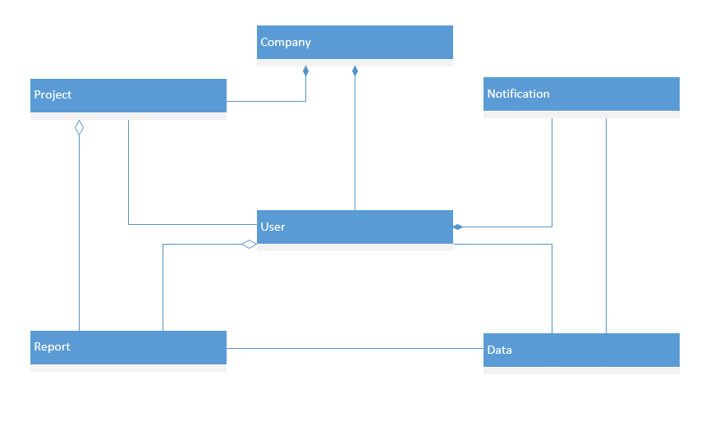

Detailed

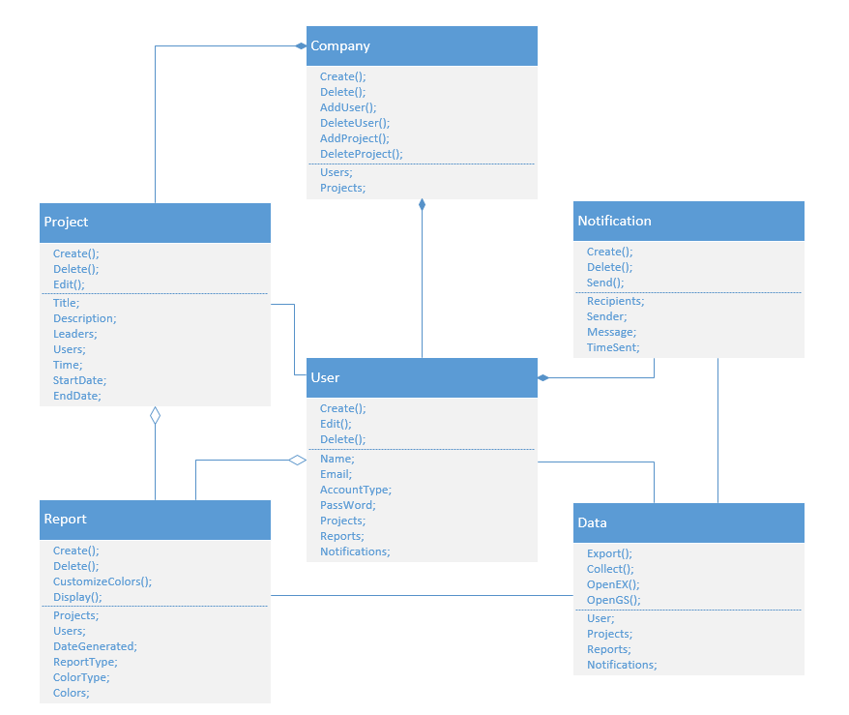

Class Specifications

Company

|  |
| --- |
| **Class Information** |
| Class Name: Company  Abstract Type: Persistence: |

|  |  |  |
| --- | --- | --- |
| **Trace-ability Information** | | |
| **Use Case ID** | **Use Case Name** | **Steps** |
|  |  |  |
|  |  |  |

|  |  |  |
| --- | --- | --- |
| **Public Methods** | | |
| **Signature** | **Preconditions** | **Post Conditions** |
|  |  |  |
|  |  |  |
|  |  |  |
|  |  |  |
|  |  |  |
|  |  |  |
|  |  |  |

|  |  |  |
| --- | --- | --- |
| **Protected Methods** | | |
| **Signature** | **Preconditions** | **Post Conditions** |
|  |  |  |
|  |  |  |

|  |  |  |
| --- | --- | --- |
| **Private Methods** | | |
| **Signature** | **Preconditions** | **Post Conditions** |
|  |  |  |
|  |  |  |

|  |  |  |  |  |  |
| --- | --- | --- | --- | --- | --- |
| **Attributes** | | | | | |
| **Name** | **Type** | **Object (Y/N)** | **Instance/Static** | **Visibility** | **Description** |
|  |  |  |  |  |  |
|  |  |  |  |  |  |

|  |  |
| --- | --- |
| **Concurrency** | |
| **Threading Issue** | **Description** |
|  |  |
|  |  |

|  |  |  |
| --- | --- | --- |
| **Major Exceptions** | | |
| **Name** | **Trigger** | **Action** |
|  |  |  |
|  |  |  |

|  |  |  |  |
| --- | --- | --- | --- |
| **Instance Information** | | | |
| **Minimum** | **Maximum** | **Mean** | **Fixed** |
|  |  |  |  |
|  |  |  |  |

|  |  |  |
| --- | --- | --- |
| **General Comments** | | |
| **Author** | **Date** | **Comment** |
|  |  |  |
|  |  |  |

Data

|  |
| --- |
| **Class Information** |
| Class Name: Data  Abstract Type: Persistence: |

|  |  |  |
| --- | --- | --- |
| **Trace-ability Information** | | |
| **Use Case ID** | **Use Case Name** | **Steps** |
|  |  |  |
|  |  |  |

|  |  |  |
| --- | --- | --- |
| **Public Methods** | | |
| **Signature** | **Preconditions** | **Post Conditions** |
|  |  |  |
|  |  |  |
|  |  |  |
|  |  |  |
|  |  |  |
|  |  |  |
|  |  |  |

|  |  |  |
| --- | --- | --- |
| **Protected Methods** | | |
| **Signature** | **Preconditions** | **Post Conditions** |
|  |  |  |
|  |  |  |

|  |  |  |
| --- | --- | --- |
| **Private Methods** | | |
| **Signature** | **Preconditions** | **Post Conditions** |
|  |  |  |
|  |  |  |

|  |  |  |  |  |  |
| --- | --- | --- | --- | --- | --- |
| **Attributes** | | | | | |
| **Name** | **Type** | **Object (Y/N)** | **Instance/Static** | **Visibility** | **Description** |
|  |  |  |  |  |  |
|  |  |  |  |  |  |

|  |  |
| --- | --- |
| **Concurrency** | |
| **Threading Issue** | **Description** |
|  |  |
|  |  |

|  |  |  |
| --- | --- | --- |
| **Major Exceptions** | | |
| **Name** | **Trigger** | **Action** |
|  |  |  |
|  |  |  |

|  |  |  |  |
| --- | --- | --- | --- |
| **Instance Information** | | | |
| **Minimum** | **Maximum** | **Mean** | **Fixed** |
|  |  |  |  |
|  |  |  |  |

|  |  |  |
| --- | --- | --- |
| **General Comments** | | |
| **Author** | **Date** | **Comment** |
|  |  |  |
|  |  |  |

Notification

|  |
| --- |
| **Class Information** |
| Class Name: Notification  Abstract Type: Persistence: |

|  |  |  |
| --- | --- | --- |
| **Trace-ability Information** | | |
| **Use Case ID** | **Use Case Name** | **Steps** |
|  |  |  |
|  |  |  |

|  |  |  |
| --- | --- | --- |
| **Public Methods** | | |
| **Signature** | **Preconditions** | **Post Conditions** |
|  |  |  |
|  |  |  |
|  |  |  |
|  |  |  |
|  |  |  |
|  |  |  |
|  |  |  |

|  |  |  |
| --- | --- | --- |
| **Protected Methods** | | |
| **Signature** | **Preconditions** | **Post Conditions** |
|  |  |  |
|  |  |  |

|  |  |  |
| --- | --- | --- |
| **Private Methods** | | |
| **Signature** | **Preconditions** | **Post Conditions** |
|  |  |  |
|  |  |  |

|  |  |  |  |  |  |
| --- | --- | --- | --- | --- | --- |
| **Attributes** | | | | | |
| **Name** | **Type** | **Object (Y/N)** | **Instance/Static** | **Visibility** | **Description** |
|  |  |  |  |  |  |
|  |  |  |  |  |  |

|  |  |
| --- | --- |
| **Concurrency** | |
| **Threading Issue** | **Description** |
|  |  |
|  |  |

|  |  |  |
| --- | --- | --- |
| **Major Exceptions** | | |
| **Name** | **Trigger** | **Action** |
|  |  |  |
|  |  |  |

|  |  |  |  |
| --- | --- | --- | --- |
| **Instance Information** | | | |
| **Minimum** | **Maximum** | **Mean** | **Fixed** |
|  |  |  |  |
|  |  |  |  |

|  |  |  |
| --- | --- | --- |
| **General Comments** | | |
| **Author** | **Date** | **Comment** |
|  |  |  |
|  |  |  |

Project

|  |
| --- |
| **Class Information** |
| Class Name: Project  Abstract Type: Persistence: |

|  |  |  |
| --- | --- | --- |
| **Trace-ability Information** | | |
| **Use Case ID** | **Use Case Name** | **Steps** |
|  |  |  |
|  |  |  |

|  |  |  |
| --- | --- | --- |
| **Public Methods** | | |
| **Signature** | **Preconditions** | **Post Conditions** |
|  |  |  |
|  |  |  |
|  |  |  |
|  |  |  |
|  |  |  |
|  |  |  |
|  |  |  |

|  |  |  |
| --- | --- | --- |
| **Protected Methods** | | |
| **Signature** | **Preconditions** | **Post Conditions** |
|  |  |  |
|  |  |  |

|  |  |  |
| --- | --- | --- |
| **Private Methods** | | |
| **Signature** | **Preconditions** | **Post Conditions** |
|  |  |  |
|  |  |  |

|  |  |  |  |  |  |
| --- | --- | --- | --- | --- | --- |
| **Attributes** | | | | | |
| **Name** | **Type** | **Object (Y/N)** | **Instance/Static** | **Visibility** | **Description** |
|  |  |  |  |  |  |
|  |  |  |  |  |  |

|  |  |
| --- | --- |
| **Concurrency** | |
| **Threading Issue** | **Description** |
|  |  |
|  |  |

|  |  |  |
| --- | --- | --- |
| **Major Exceptions** | | |
| **Name** | **Trigger** | **Action** |
|  |  |  |
|  |  |  |

|  |  |  |  |
| --- | --- | --- | --- |
| **Instance Information** | | | |
| **Minimum** | **Maximum** | **Mean** | **Fixed** |
|  |  |  |  |
|  |  |  |  |

|  |  |  |
| --- | --- | --- |
| **General Comments** | | |
| **Author** | **Date** | **Comment** |
|  |  |  |
|  |  |  |

Report

|  |
| --- |
| **Class Information** |
| Class Name: Report  Abstract Type: Persistence: |

|  |  |  |
| --- | --- | --- |
| **Trace-ability Information** | | |
| **Use Case ID** | **Use Case Name** | **Steps** |
|  |  |  |
|  |  |  |

|  |  |  |
| --- | --- | --- |
| **Public Methods** | | |
| **Signature** | **Preconditions** | **Post Conditions** |
|  |  |  |
|  |  |  |
|  |  |  |
|  |  |  |
|  |  |  |
|  |  |  |
|  |  |  |

|  |  |  |
| --- | --- | --- |
| **Protected Methods** | | |
| **Signature** | **Preconditions** | **Post Conditions** |
|  |  |  |
|  |  |  |

|  |  |  |
| --- | --- | --- |
| **Private Methods** | | |
| **Signature** | **Preconditions** | **Post Conditions** |
|  |  |  |
|  |  |  |

|  |  |  |  |  |  |
| --- | --- | --- | --- | --- | --- |
| **Attributes** | | | | | |
| **Name** | **Type** | **Object (Y/N)** | **Instance/Static** | **Visibility** | **Description** |
|  |  |  |  |  |  |
|  |  |  |  |  |  |

|  |  |
| --- | --- |
| **Concurrency** | |
| **Threading Issue** | **Description** |
|  |  |
|  |  |

|  |  |  |
| --- | --- | --- |
| **Major Exceptions** | | |
| **Name** | **Trigger** | **Action** |
|  |  |  |
|  |  |  |

|  |  |  |  |
| --- | --- | --- | --- |
| **Instance Information** | | | |
| **Minimum** | **Maximum** | **Mean** | **Fixed** |
|  |  |  |  |
|  |  |  |  |

|  |  |  |
| --- | --- | --- |
| **General Comments** | | |
| **Author** | **Date** | **Comment** |
|  |  |  |
|  |  |  |

User

|  |
| --- |
| **Class Information** |
| Class Name: User  Abstract Type: Persistence: |

|  |  |  |
| --- | --- | --- |
| **Trace-ability Information** | | |
| **Use Case ID** | **Use Case Name** | **Steps** |
|  |  |  |
|  |  |  |

|  |  |  |
| --- | --- | --- |
| **Public Methods** | | |
| **Signature** | **Preconditions** | **Post Conditions** |
|  |  |  |
|  |  |  |
|  |  |  |
|  |  |  |
|  |  |  |
|  |  |  |
|  |  |  |

|  |  |  |
| --- | --- | --- |
| **Protected Methods** | | |
| **Signature** | **Preconditions** | **Post Conditions** |
|  |  |  |
|  |  |  |

|  |  |  |
| --- | --- | --- |
| **Private Methods** | | |
| **Signature** | **Preconditions** | **Post Conditions** |
|  |  |  |
|  |  |  |

|  |  |  |  |  |  |
| --- | --- | --- | --- | --- | --- |
| **Attributes** | | | | | |
| **Name** | **Type** | **Object (Y/N)** | **Instance/Static** | **Visibility** | **Description** |
|  |  |  |  |  |  |
|  |  |  |  |  |  |

|  |  |
| --- | --- |
| **Concurrency** | |
| **Threading Issue** | **Description** |
|  |  |
|  |  |

|  |  |  |
| --- | --- | --- |
| **Major Exceptions** | | |
| **Name** | **Trigger** | **Action** |
|  |  |  |
|  |  |  |

|  |  |  |  |
| --- | --- | --- | --- |
| **Instance Information** | | | |
| **Minimum** | **Maximum** | **Mean** | **Fixed** |
|  |  |  |  |
|  |  |  |  |

|  |  |  |
| --- | --- | --- |
| **General Comments** | | |
| **Author** | **Date** | **Comment** |
|  |  |  |
|  |  |  |